MACH4METAL

metalworking machinery
Transito 21,
6909 DA BABBERICH
Tel. +31 (0)622453620
mach4metal@hotmail.com
www.mach4metal.com
Bank No : 66.52.13.883
IBAN : NL33 INGB 0665 2138 83
BIC : INGBNL2A

VDF Boehringer DUE 500 x 1000
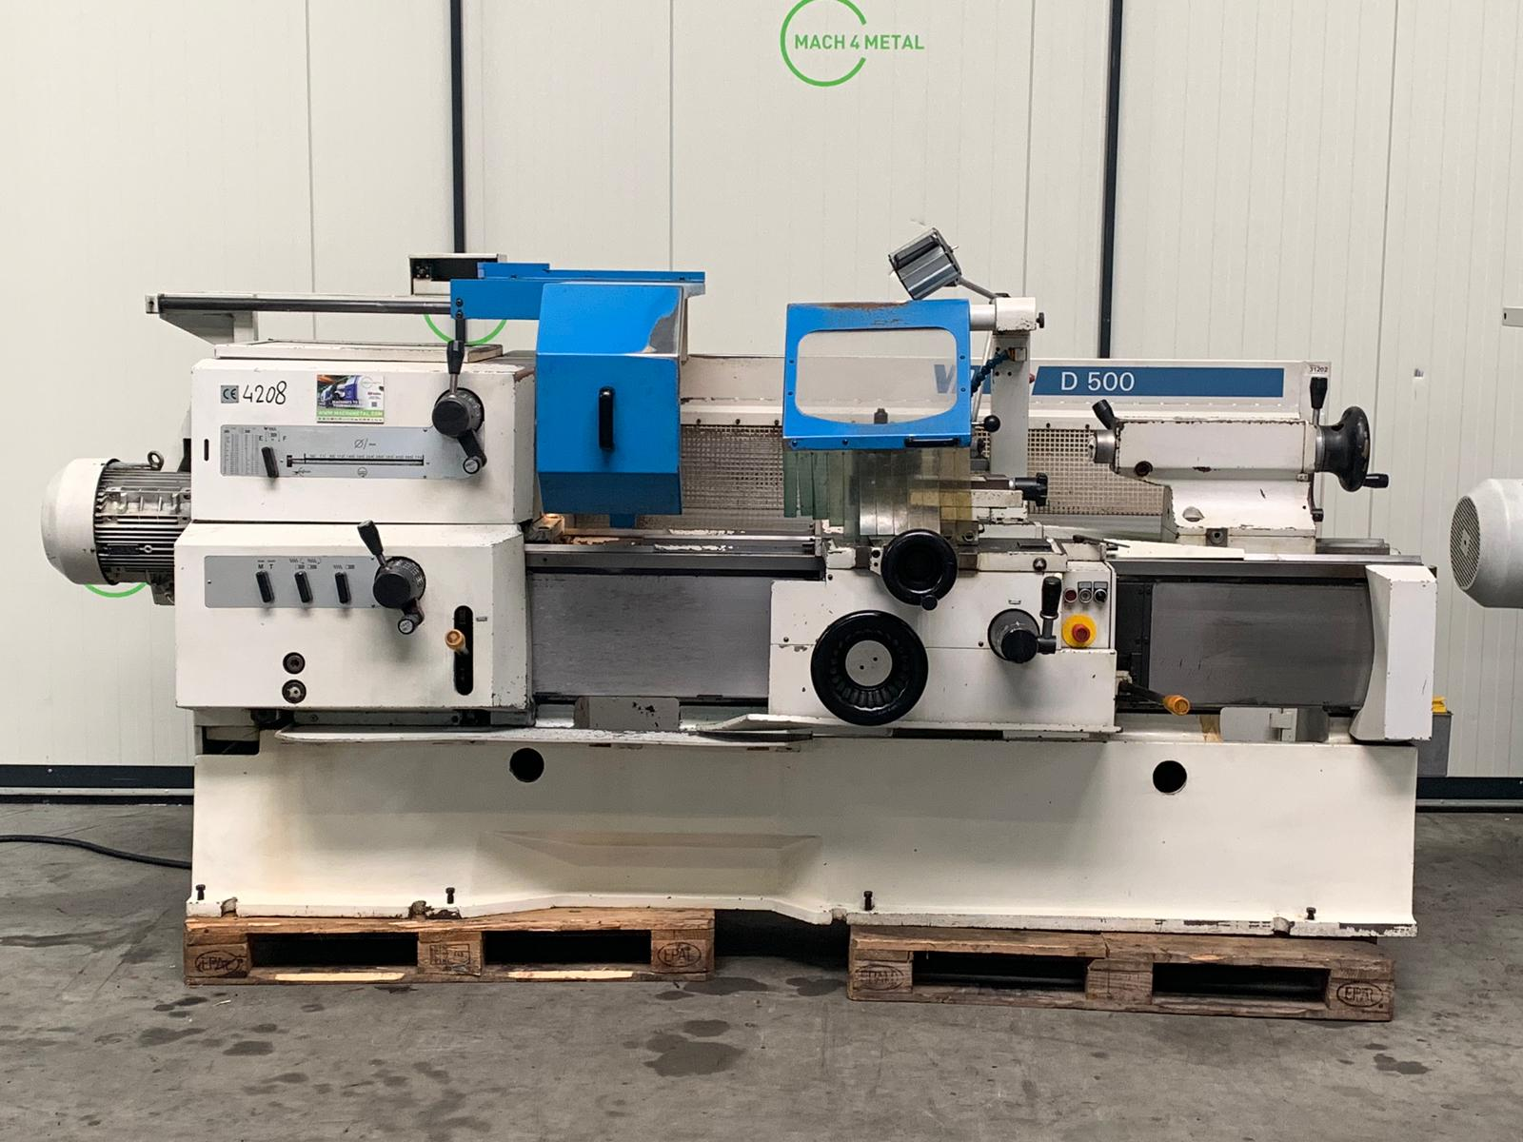

- Make : VDF BOEHRINGER
- Type : DUE 500
- YOP : 2004
- Serial : 508

- Swing over bed : 520 Ø
- Swing over cross slide : 315
- Spindle bore : 62

- Gap length : 160
- Turning length : 1.000
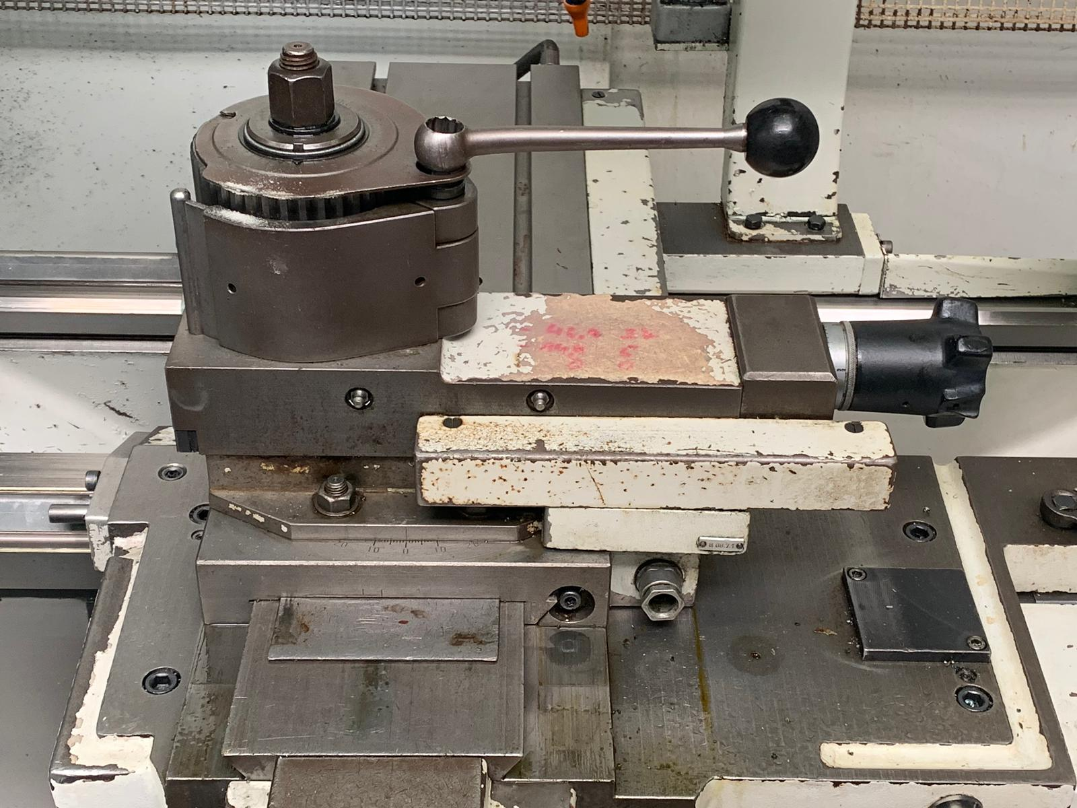
- Bed width : 360
- Speed range : 2.240

- Power : 11 KW
- Pinole taper : Mk 5
- Pinole Ø : 80

- Dimensions
- Length : 3.200
- Width : 1.800
- Height : 1.900
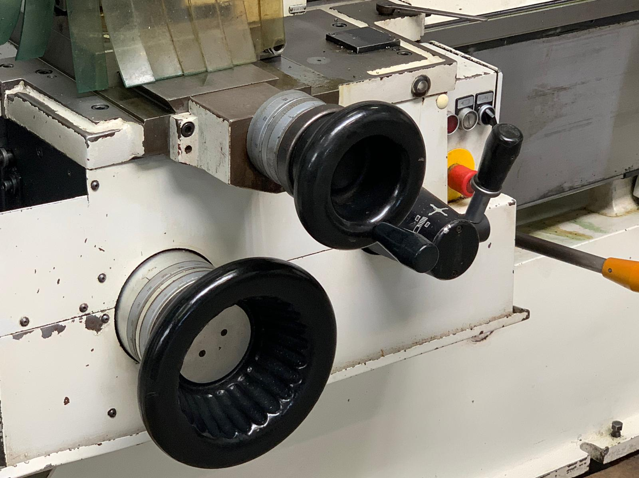
- Weight : 4.000

- Incl. Tool system
- Incl. Feed
- Incl. Coolant system
- CE Mark

Please Note: The above information has been obtained to the best of our ability and belief from, and from the manufacturers where possible. It is given in good faith, but its accuracy can not be guaranteed. Accordingly, it will not form a representation or constitute contractual terms. We advise you to check any vital details

